**Introduction to Filing**

**Files and Stream**

C views each file simply as a sequential stream of bytes. Each file ends either with an end-of-file marker or at a specific byte number recorded in a system-maintained, administrative data structure. When a file is opened, a stream is associated with the file. Three files and their associated streams are automatically opened when program execution begins—the standard input, the standard output and the standard error. Streams provide communication channels between files and programs. For example, the standard input stream enables a program to read data from the keyboard. The standard output stream enables a program to print data on the screen. Opening a file, returns a pointer to a FILE structure (defined in <stdio.h>) that contains information used to process the file. This structure includes a file descriptor, i.e., an index into an operating system array called the open file table. Each array element contains a file control block (FCB) that the operating system uses to administer a particular file. The standard input, standard output and standard error are manipulated using file pointers stdin, stdout and stderr.

**Example for Writing File** 

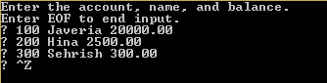

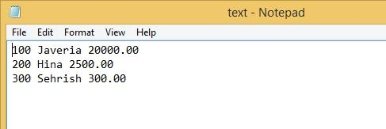

**Example of Reading Data**



|  |
| --- |
| **QUESTION**  Write a C program to keep records and perform statistical analysis for a class of 20 students. The information of each student contains ID, Name, Sex, quizzes Scores (2 quizzes per semester), mid-term score, final score, and total score. All the records must be store in the file and you must read the scores <50, <80 and <100 until users selects the end file option.  **QUESTION**  You’re the owner of a hardware store and need to keep an inventory that can tell you what tools you have, how many you have and the cost of each one. Write a program that initializes the file "hardware.txt" to 10 empty records, lets you input the data concerning each tool, enables you to list all your tools, lets you delete a record for a tool that you no longer have and lets you update any information in the file. The tool identification number should be the record number. Use the following information to start your file:    **QUESTION**  Using C, create a file named budge.txt that contains three equal-length columns of numbers, like this:  -462.13 486.47 973.79  755.42 843.04 -963.67  442.58 -843.02 -462.86  -233.93 -821.67 399.59  -379.65 -556.37 837.46  55.18 -144.93 -93.15  533.73 804.64 -66.25  -922.12 914.68 -264.67  -600.27 -838.59 747.02  -962.97 49.96 -677.79  Now write a program named budget.c that reads this file and adds up the numbers in each column.  The program’s output should look like this:  Column sums are: -1774.16 -105.79 429.47  **QUESTION**  Write a C++ Program to Count Digits, Alphabets and Spaces using File Handling |
|  |